

Recruitment Pack
SHOP MANAGER

Contents
- A message from our CEO, Sonya Currey
- Services we provide
- Our Vision and Values
- Our Strategy 2019-2025
- Our Funding
- Job description
- Person specification
- Organisational chart
- Benefits of the job
- How to apply


1. A message from our CEO, Sonya Currey

I am really pleased that you are interested in learning more about this exciting opportunity to join the team here at St. Rocco’s.

This pack aims to give you some of the information that will help you decide whether this is the right opportunity for you and to prepare your application.

St. Rocco’s holds a very special place in the heart of our Warrington community and the St. Rocco’s team
are fully committed to the stewardship this brings. Whether part of our clinical or support services staff and volunteer teams, there is a passion to care with the utmost dignity and respect for all who experience our services. This shared vision means that by joining the St. Rocco’s team you will quickly be able to see how your role benefits our patients and those important to them and therefore, the value of your efforts.

We are at a pivotal time in the St. Rocco’s journey with a rapidly changing health and social care landscape that is driving a strategy refresh. Building on a strong foundation we are refocusing our ambitions, something that we have described in more detail as part of this pack.
If this sounds like something that you would like to become a part of, we would be very pleased to hear from you.

Thank you for your interest in joining us and we look forward to reading your application.

2. Services We Provide

St Rocco’s supports people in the Warrington community from the moment they are diagnosed with an illness that is no longer curable. We look after people over the age of 18 years with any kind of life-limiting illness including both malignant and non-malignant diseases, such as end stage, heart failure, respiratory conditions, and neurological diseases.
We aim to be available to our patients and those important to them every step of the way, helping them to make every moment count and to stay as well as possible for as long as possible. We achieve this by working in partnership with other healthcare professionals collaboratively to promote skilled, compassionate palliative care of the highest quality.

Warrington Integrated Palliative Care Hub
- A single point of referral based at St Rocco’s for access to palliative care services across Warrington for health and social care professionals, patient, and carers. This is a co-located multi-professional service that has access to nursing, medical and social work expertise to ensure we can affect a timely response whilst offering continuity through a single contact.


Community Outpatient Services
- Our outpatient services are run by senior doctors with the focus around complex symptom control and improving quality of life. The Hospice outpatient clinics have been running for over 12 years.


- This service provides psychological support for patients and bereavement services for their loved ones, including our community-based Bereavement Cafés.

In Patient Unit
- We have a registered capacity of 10 inpatient beds, providing 24-hour care and support by a team of specialist palliative care staff to provide complex symptom management and end of life care.
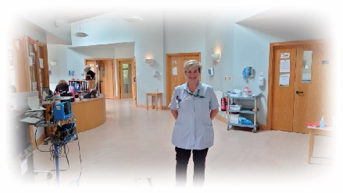


Hospice at Home
- Our Hospice at Home service supports people to remain at home if that is their choice. A team of experienced nurses oversee and coordinate the service and healthcare assistants give practical care and psychological support to patients and their families.

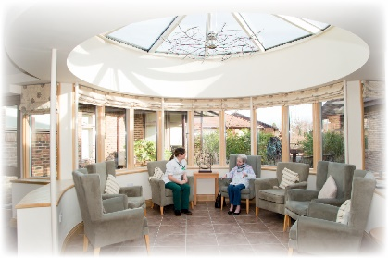
Vitality Centre
- From this centre based at our main hospice site, we provide a range of services supporting patients to stay as well as possible for as long as possible. Services include complementary and activity therapies and dedicated symptom control clinics.

3. Our Vision and Values

Here at St. Rocco’s our mission is...
“Support everyone in our community diagnosed with a life limiting disease, and those who matter to them, to live well and towards the end of their life have a dignified death in a place of their choice.”
We aim to deliver a caring experience where people feel warmly welcomed into hospice care through upholding our value in all that we do.

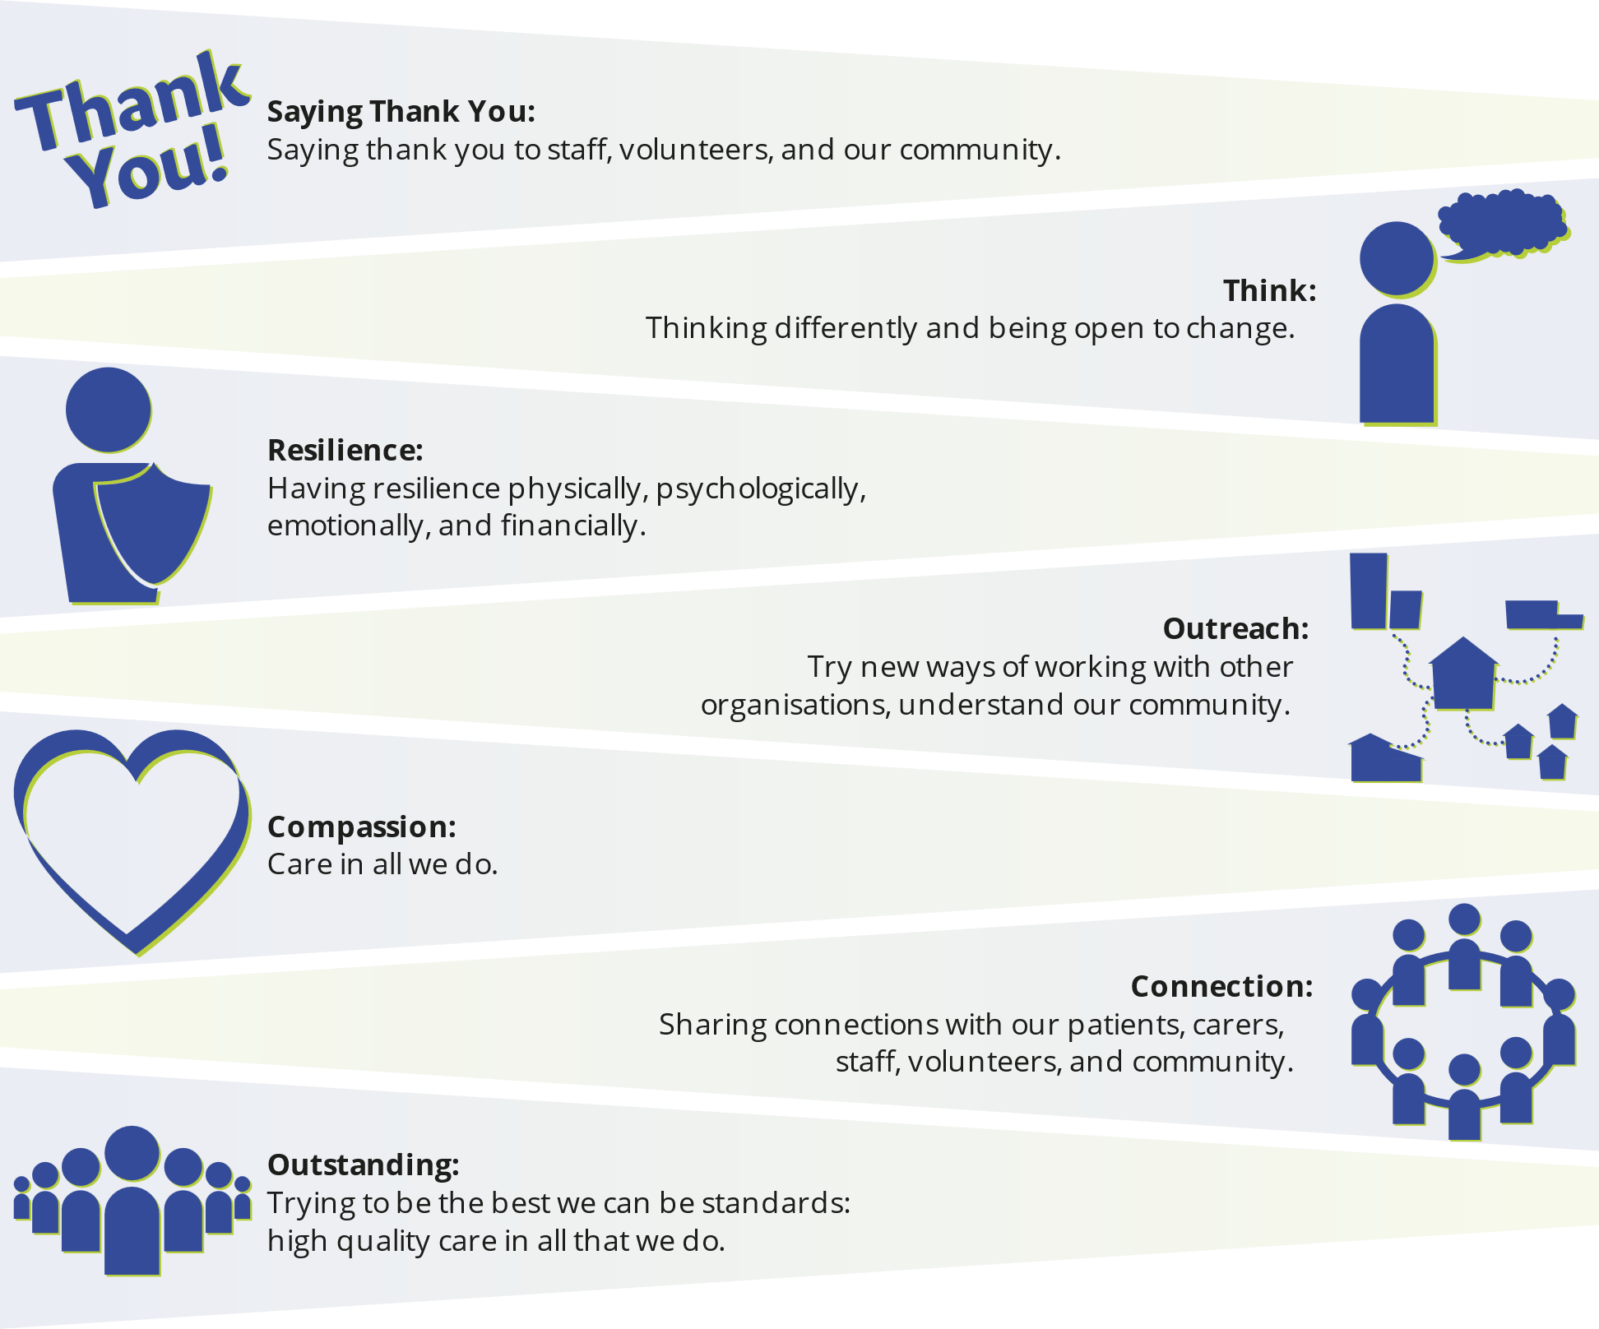
Our values very much reflect who we are as an organisation

4. Our Strategy 2019-2025
As our external environment changes, we are working to develop our current strategy, increasingly focussing on four key areas:


Increasing the reach of our services into our community, by partnering for better outcomes and impact for our community.


Investing in our people to be a great place to work and volunteer, where skills and needs are recognised.


Developing our operational excellence through a resilient structure and infrastructure that meets our regulatory requirements.

Strengthening our financial sustainability and resilience to ensure we can continue to respond to the needs of our community into
the future.


5. Our Funding

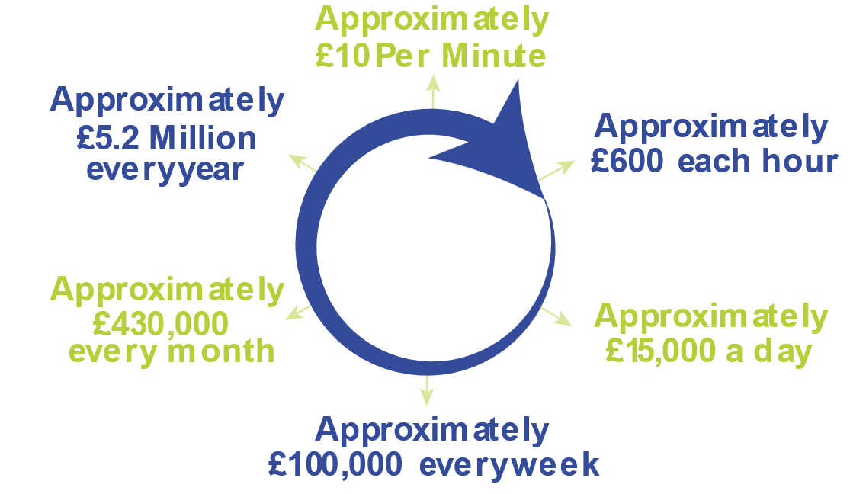
St Rocco’s, as a local charity costs around £5.2 Million to run per year.

The funding received from NHS services via Integrated Care Board (ICB) Cheshire and Merseyside Warrington Place (previously Warrington Clinical Commissioning Group) is spent directly on patient services.
Around 80% of our funding is generated by our community fundraising, retail operations and legacies and we are incredibly grateful for the
support that we receive from the people of Warrington. The chart below indicates the breakdown of this activity in the year ending December 2021.
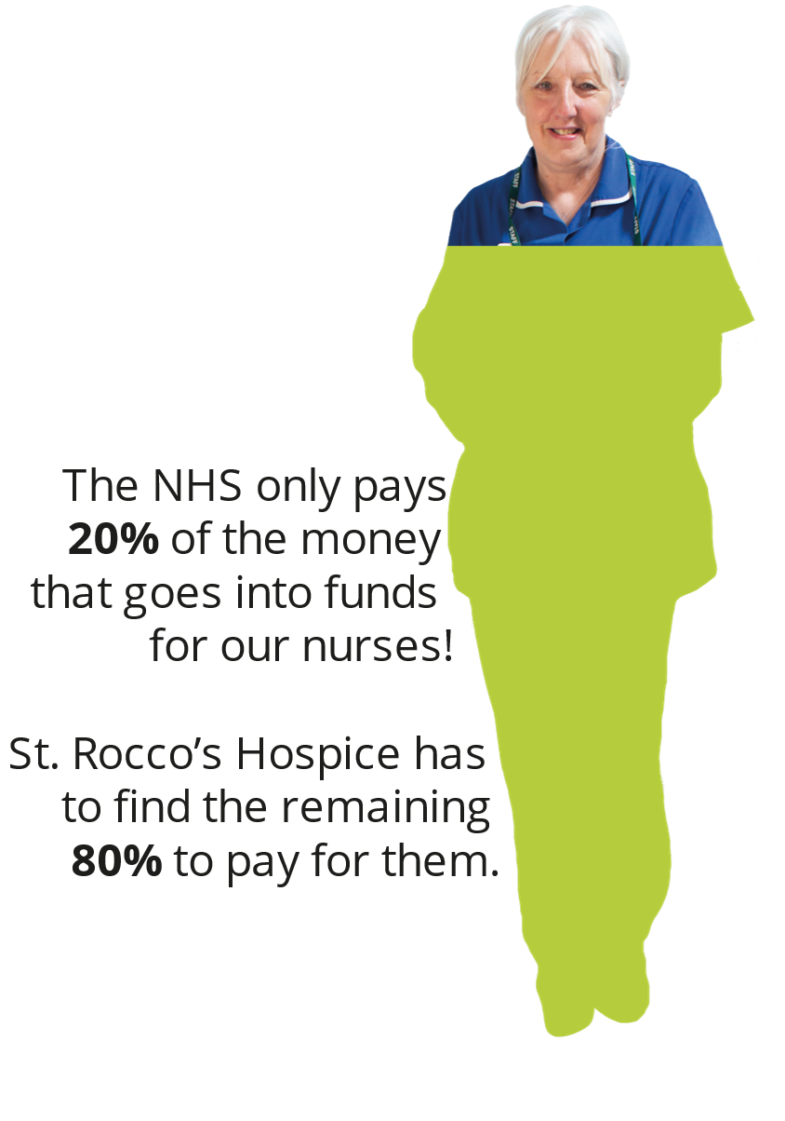
The increasing global economic pressures and financial landscape means that we are working hard to further develop our effectiveness in this area to respond to the challenges ahead

6. Job Description
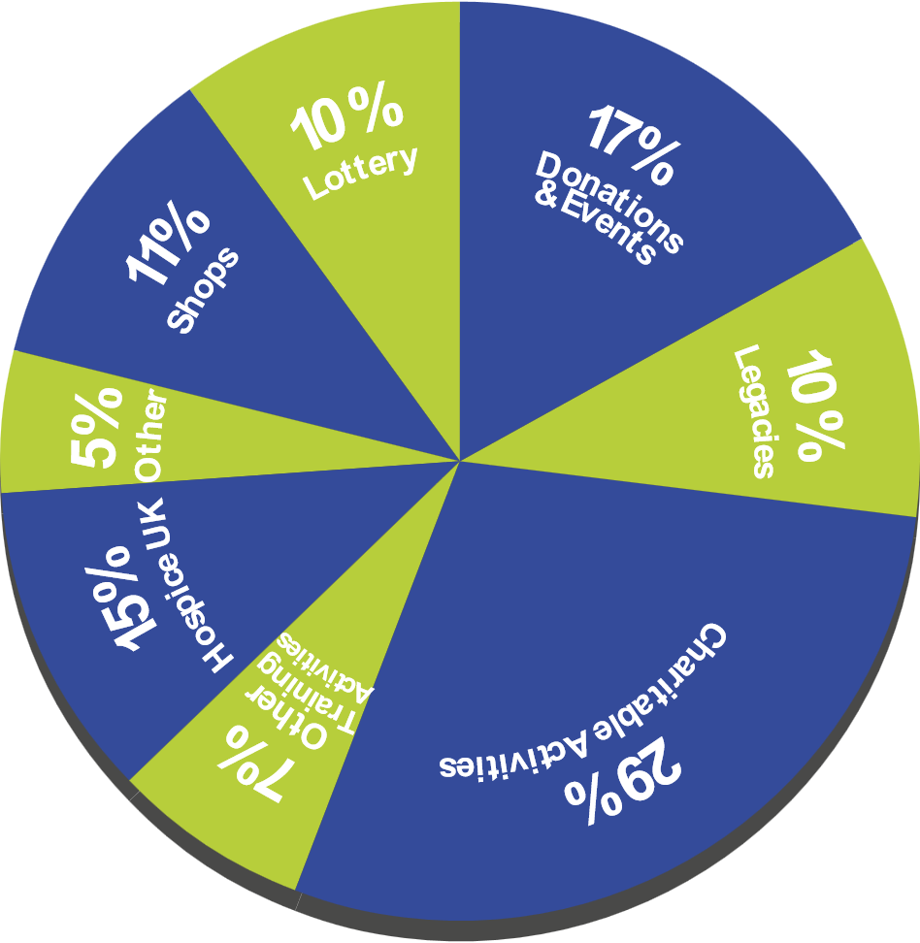

St. Rocco's Charity Shop Manager

Job Description

Job Title: Responsible to: | Shop Manager  Retail Support Manager, who will provide regular support and supervision meetings at agreed intervals
Directly Managing: | Volunteer Day Managers and Teams of Volunteers

Purpose of the Job
To be responsible for the effective operation of the shop with responsibility for:

- Managing the day to day running of the shop.
- Optimising sales.
- Maintaining effective stock management and merchandising.
- Managing and training shop volunteers.
- Carrying out shop administration.
- Taking necessary action to arrange repairs and maintenance of the premises.
- Ensuring adequate security.
- Enforcing health and safety policy and procedures.

Tasks & Responsibilities

Strategic Role as Shop Manager
- To take day to day responsibility for managing your shop.
- To brief the Retail Support Manager at regular agreed intervals (and immediately if urgent) on progress in your shop.
- To propose action to them for improvements in operations.
- To maintain an awareness of developments in local shops, especially in the charity/low cost sector, updating the Retail Support Manager and Head of Commercial Development, as required.
- To maintain an awareness of the work of St. Rocco's Hospice and relevant local or national issues through press, media and local views.
- To maintain and develop good channels of communication with colleagues in other St. Rocco’s Hospice Shops, local communities and organisations.
- To assist the Retail Support Manager as required in area wide initiatives, for example new shop openings.
- To provide cover for Shop Managers from time to time in other stores, as required by the Retail Support Manager. This would usually be through negotiation and mutual agreement, although in an emergency you may be asked to cover at short notice.

Optimising Sales

- To ensure the shop meets sales targets set by the Retail Support Manager.
- To promote Gift Aid sign up and repeat donations to maximise Gift Aid income.
- To initiate marketing campaigns and sales promotions to increase sales.
- To ensure the shop is competing effectively with local competitors.

- To ensure all staff maintain a high standard of customer care.
- To promote the store in the local community through initiatives, for example initiating stock appeals by organizing local leaflet distribution.
- To promote St. Rocco’s Lottery ticket sales and Lottery sign ups.
- To maximise the sales potential of new goods and Christmas cards.

Maintaining Effective Stock Management & Merchandising

- To supervise and maximise the efficiency of the stock transfer system.
- To control pricing in line with company policy.
- To ensure the highest possible resale value of donated stock.
- To control coding and processing of stock and to ensure quality control.
- To apply company display, merchandising and window dressing standards.
- To control stock density and rotation.
- To initiate local stock and sales promotions.

Staff Management & Training

- To take day to day responsibility for managing and delegating work to the Volunteer Day Managers & other volunteers ensuring satisfactory performance.
- To provide adequate supervision for the Volunteer Day Managers.
- To provide training for all shop volunteers.
- To recruit volunteers.
- To lead and develop the volunteer team in your shop, encouraging effective communication, setting objectives, initiating work plans and helping to foster a positive team spirit through regular team meetings.
- To attend training programmes and liaise with/attend team meetings of managers in your area.

Administration

- To complete daily/weekly sales returns and brief Retail Support Manager as required.
- To ensure shop costs do not exceed agreed budget.
- To ensure that all Gift Aid administration is completed accurately.
- To ensure that Data Protection and Information Governance procedures are followed.
- To apply Trading Standards Regulations in the shop and ensure staff are aware of these.
- To apply cash management and security procedures.
- To take action to ensure the shop is adequately staffed, setting and maintaining volunteer rotas.
- To control and requisition shop supplies.
- To process post.
- To bank takings using agreed banking procedures.

Premises Management
- To ensure shop housekeeping is to company standard.
- To take day to day responsibility for shop exterior.
- To ensure all shop equipment is kept in good working order
- To inform Retail Support Manager of necessary repairs and maintenance.

Security

- To act as main key holder and delegate key holding to other volunteers within

procedural guidelines.
- To ensure the security of shop takings.
- To provide best circumstances for the personal security of volunteers.
- To ensure that security procedures are understood and implemented by all volunteers.

Health & Safety
- To apply company Health & Safety regulations in accordance with the Hospice guidelines by:
- Maintaining Health & Safety records
- Undertaking required fire drills.
- Ensuring Fire Equipment is correctly sited and serviced.
- Ensuring electrical equipment is properly maintained.
- Implementing risk assessment procedures as stated in the shop manual.
- To ensure that health and safety procedures are understood and implemented by all volunteers.

General

- To carry out these tasks and responsibilities with an understanding of and commitment to St Rocco’s Hospice equal opportunities policy.
- To use new technology as required.
- To do all within your powers to keep company property secure and in good working order.
- To carry out any additional duties within the spirit of the post as required by the Retail Support Manager.
- To build and maintain relationships with the wider hospice Income Generation Team.
- To build and maintain a strong and pro-active relationship with the Voluntary Service Team.

SAFEGUARDING DUTY
“It is the responsibility of the post holder to be aware of and follow the legislation and guidance regarding Safeguarding Adults and Children as stated in the Hospice Safeguarding Policy. This applies to all staff regardless of which member of the family is the primary client. The post holder is responsible for ensuring they receive the appropriate level of safeguarding training according to their role”.

ASSURANCE STATEMENT
The purpose of this job description is to outline levels of responsibility and accountability of this post, to ensure that all work undertaken by our staff is identified and lines of accountability are clear.
It is the responsibility of all employees to adhere to general policies and procedures as detailed in the Staff Handbook and other individual policies.

The above Job Description does not purport to be an exhaustive list of duties and responsibilities. The post holder will be expected to undertake additional duties as the requirements of the post change.

----------------------------------------------------------------------------------------------------------------------------------- CHANGES TO THIS JOB DESCRIPTION
Post holders have a responsibility to discuss any significant job changes with their line manager at the time the change occurs and agree any permanent substantial change.

Person Specification

TITLE: Shop Manager
DEPARTMENT: Retail Operations

Criteria for selection | Essential | Desirable
Education/Qualifications/Experience  - Experience of working in a similar retail environment  - Management experience  - The ability to coach and motivate a team  - Experience of recruiting and working with volunteers | ✓  ✓  ✓ | ✓
Knowledge/experience/skills | ✓ | ✓
- Physically able to carry heavy boxes and bags of donated | ✓ | ✓
items. (For which training will be given) | ✓ | ✓
- Good administrative skills | ✓ | ✓
- Good communication skills | ✓ | ✓
- Commitment to equal opportunities | ✓ | ✓
- Experience of dealing with the public | ✓ | ✓
- Experience of keeping records | ✓ | ✓
- Experience of organising or managing the work of other people | ✓ | ✓
- Experience of dealing with money |  | ✓
- Ability to prioritise and organise workload | ✓ | ✓
- Good time management | ✓ | ✓
- Ability to work on own initiative and as part of a team | ✓ | ✓
Personal Qualities | ✓
- Commitment and enthusiasm for the role | ✓
- Adaptability and flexibility | ✓
Additional Requirements | ✓ | ✓
- Experience or talent for making displays. | ✓ | ✓
- Experience of working with volunteers. | ✓
- A clean current full driving licence. | ✓ | ✓

7. Organisation Chart

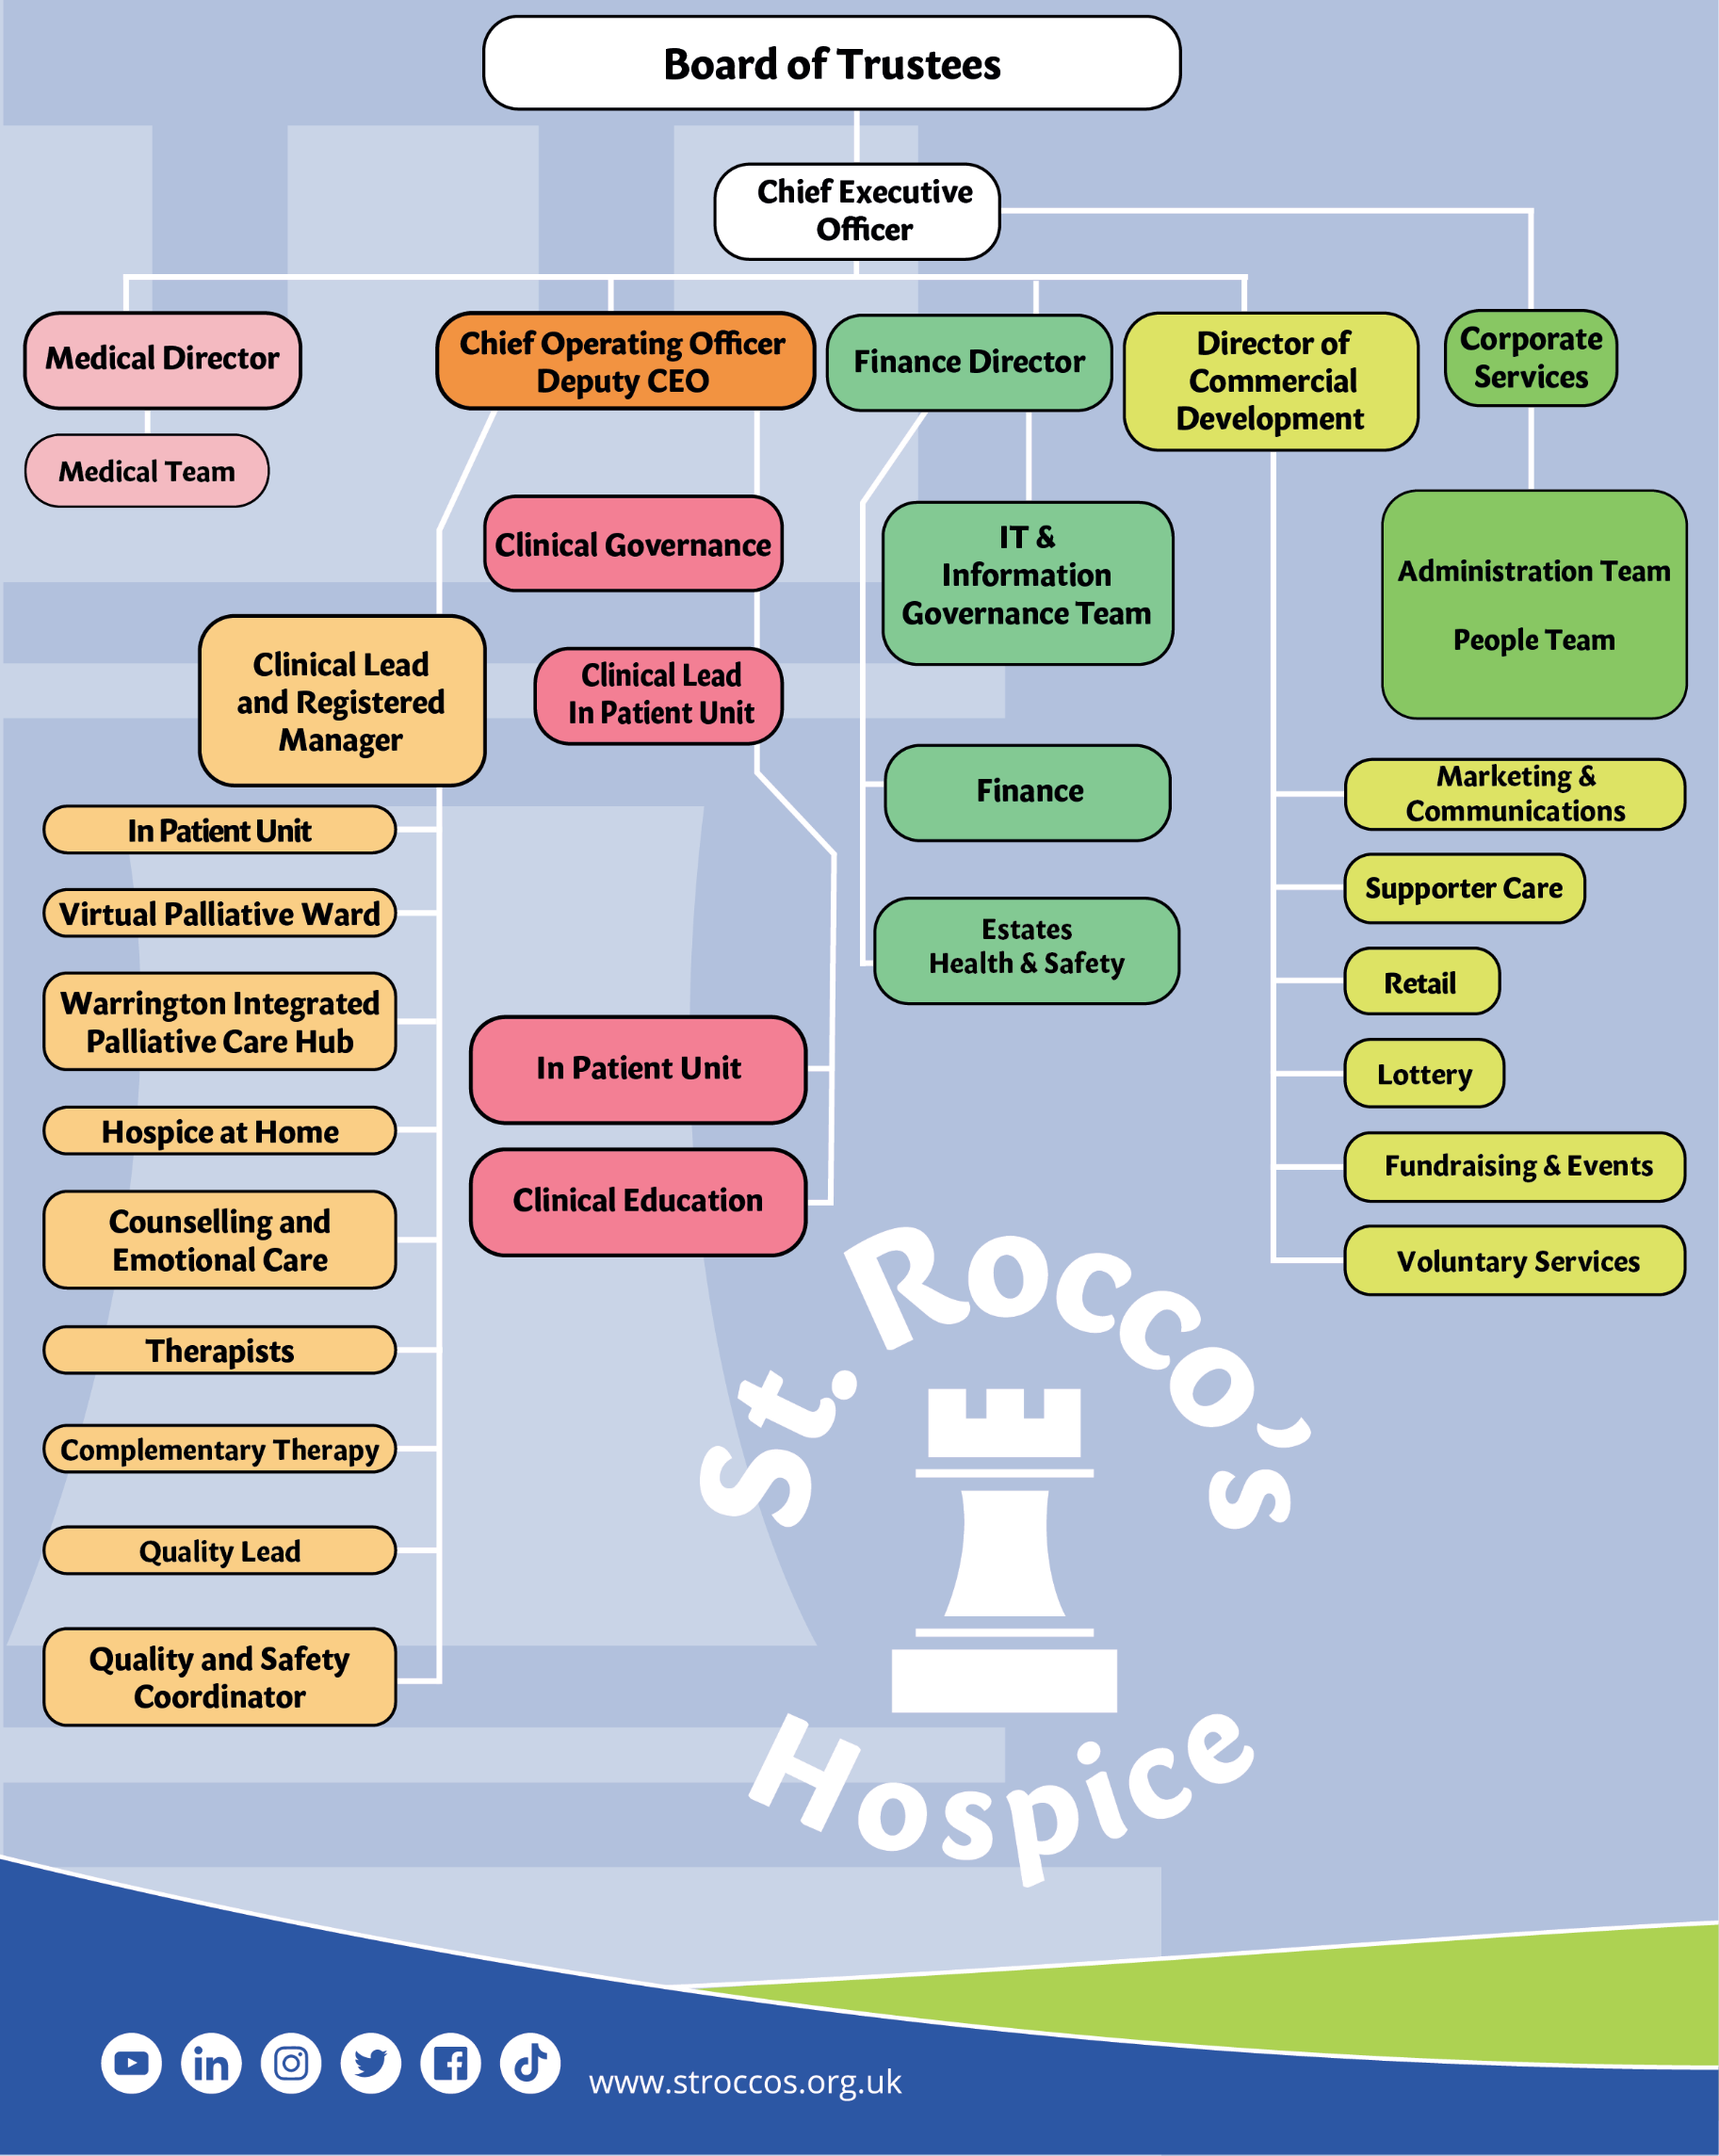

8. Benefits


Being part of the St. Rocco’s team gives you access to a great range for benefits, including:

• 35 days annual leave, including public holidays


• A contributory pension scheme, offering up to 7% employer’s contribution


• Health cash plan, offering reimbursement for a range of treatments including dental, optical, wellbeing, and complementary therapies


• Death in service benefit of twice your annual salary

• Discounted gym membership

• Retail discounts and savings on holidays and days out

• Confidential employee assistance program


• A flexible approach to working hours and location, including hybrid working

• Being part of a warm and fun organisation where we support one another to achieve amazing things

9. How to Apply

If you have the skills and experience that we are looking for, we’d love to hear from you.

If you have any questions or would like to know more about us or the role, please drop us a line at recruitment@stroccos.org.uk

Please apply via the link on our website: https://hr.breathehr.com/v/shop-manager-30038

